Late. Manikrao Govindrao Khadse Gramin Vikas Sanstha, Roahani
DNYANBHARATI COLLEGE DEOLI
Affiliated to Rashtrasant Tukdoji Maharaj Nagpur University,
Nagpur
Website: http://dyanbharaticollege.com/

3.2.2.

Number of the Workshops/Seminar/Conferences including Programs on Reserch Methodology, Intellectual Property Right and Entrepreneurship during the Last Five Years.
Brouchers, Photos and Reports.

Academic Session 2022-23
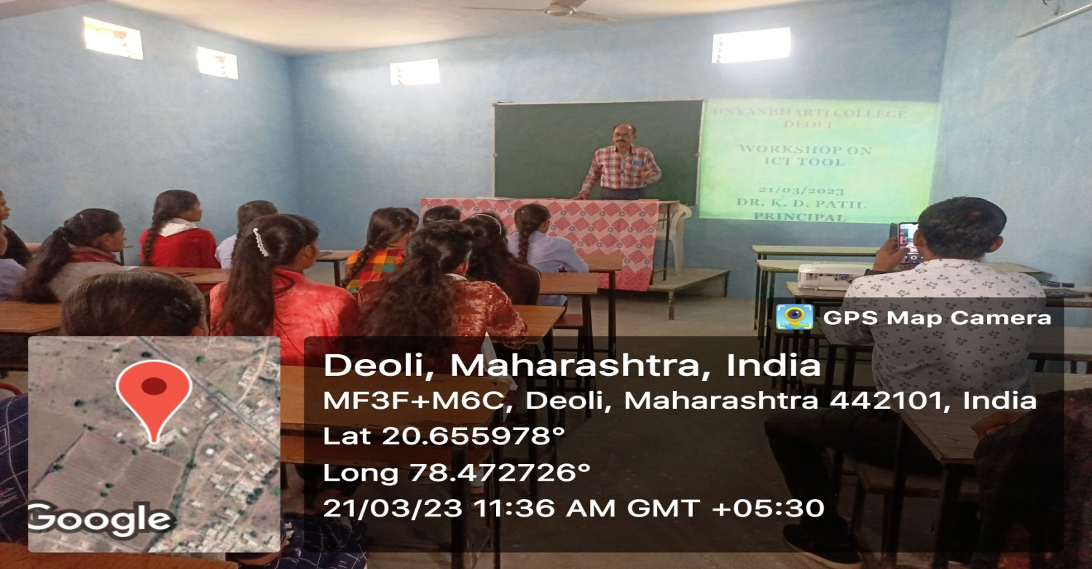
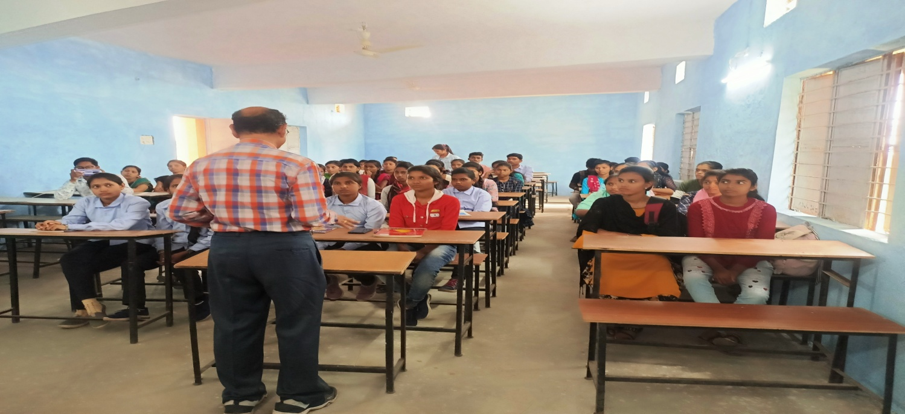
Report of the Workshop
Dnyanbharati College has organized the Workshop on ICT Tools on dated 21/03/2023. Dr. K. D. Patil was the Resource Person for this program. Prof. A. G. Adkane has given the Introductory Speech there were 50 Participants for this workshop. Prof. V. V. Takpire has given the Vote of Thanks.

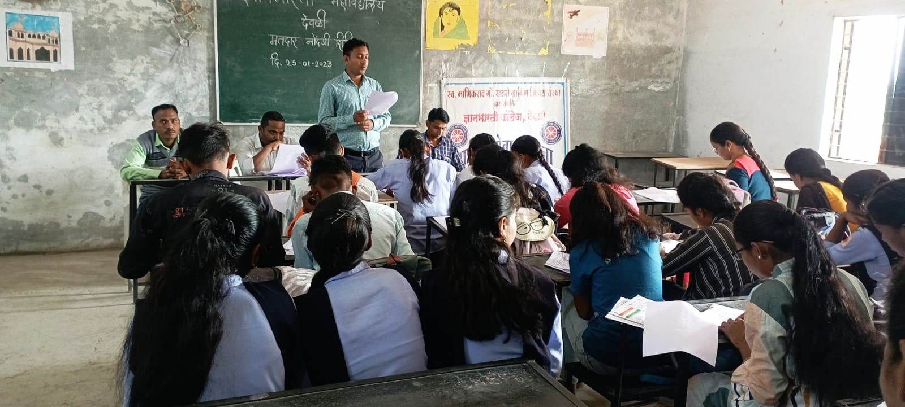
VOTER REGISTRATION WORKSHOP
Department of Marathi Dnyanbharatin College Deoli has organized Voter Registration Workshop on 25/01/2023. Officer from Deoli Tahsil Office Shri. Santosh Rathod was invited for the program. Dr. M. P. Dhone has taken the effort to amke the program successful. About 100 students of the college have participated for this workshop at the end Prof. Shamina has given the Vote of Thanks.

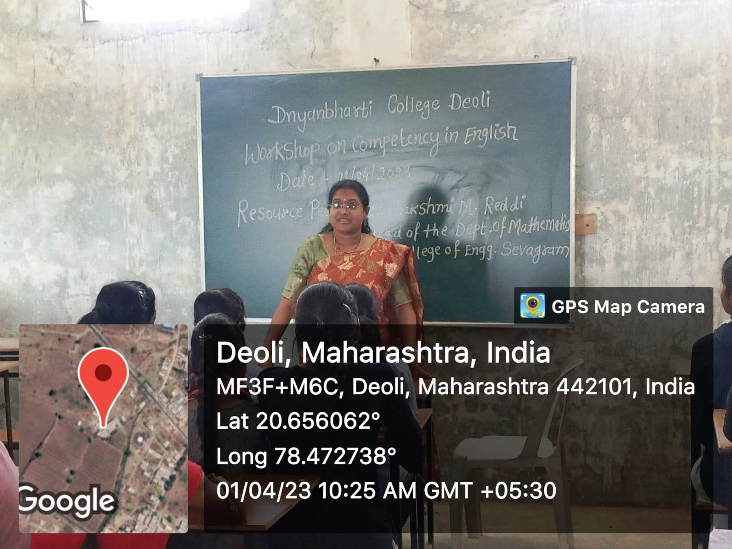
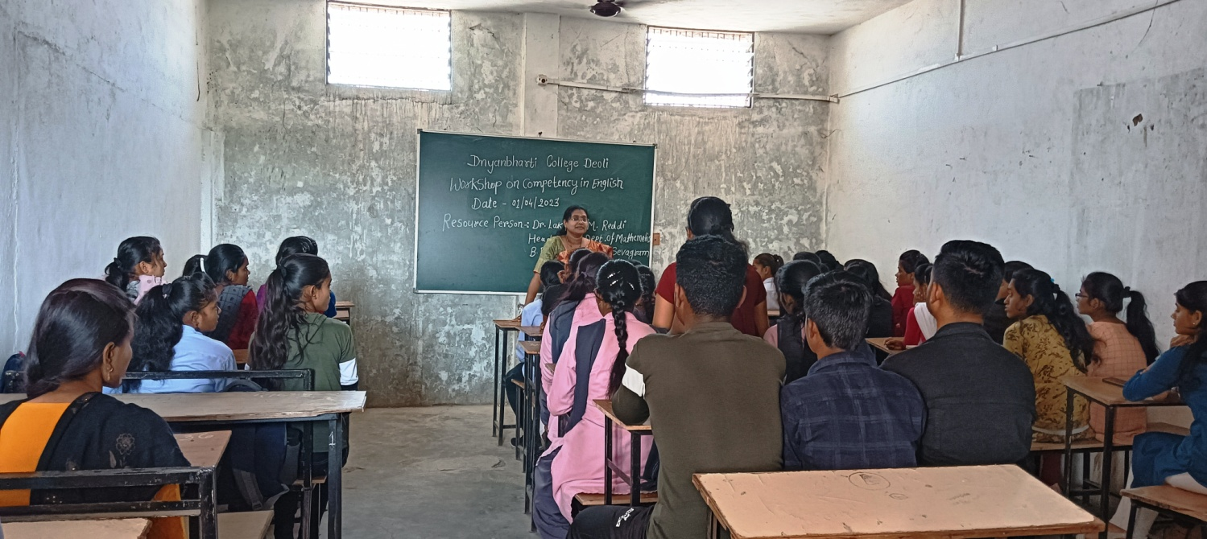
WORKSHOP ON COMPETENCY IN ENGLISH
Dept. Of English Dnyanbharati College Deoli has organized the Workshop on Competency in English on 01/04/2023, Dr. Lakshmi Madireddy, HOD, B. D. College of Engineering Sevagram was the Resource Person for this workshop. About 40 Students were presents for the Workshop. Dr. Lakshmi Madireddy has explain wisely the use of English Communication in the Society. Finally Prof. A. D. Barange has given the Vote of Thanks.

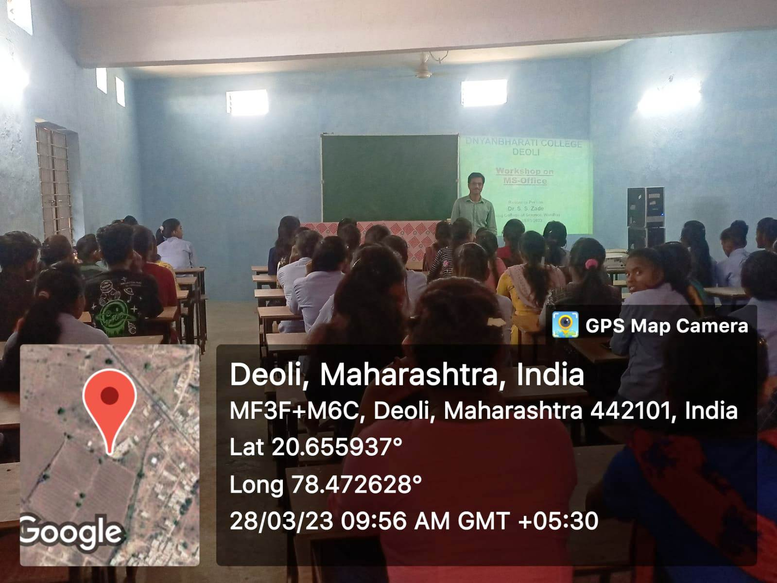
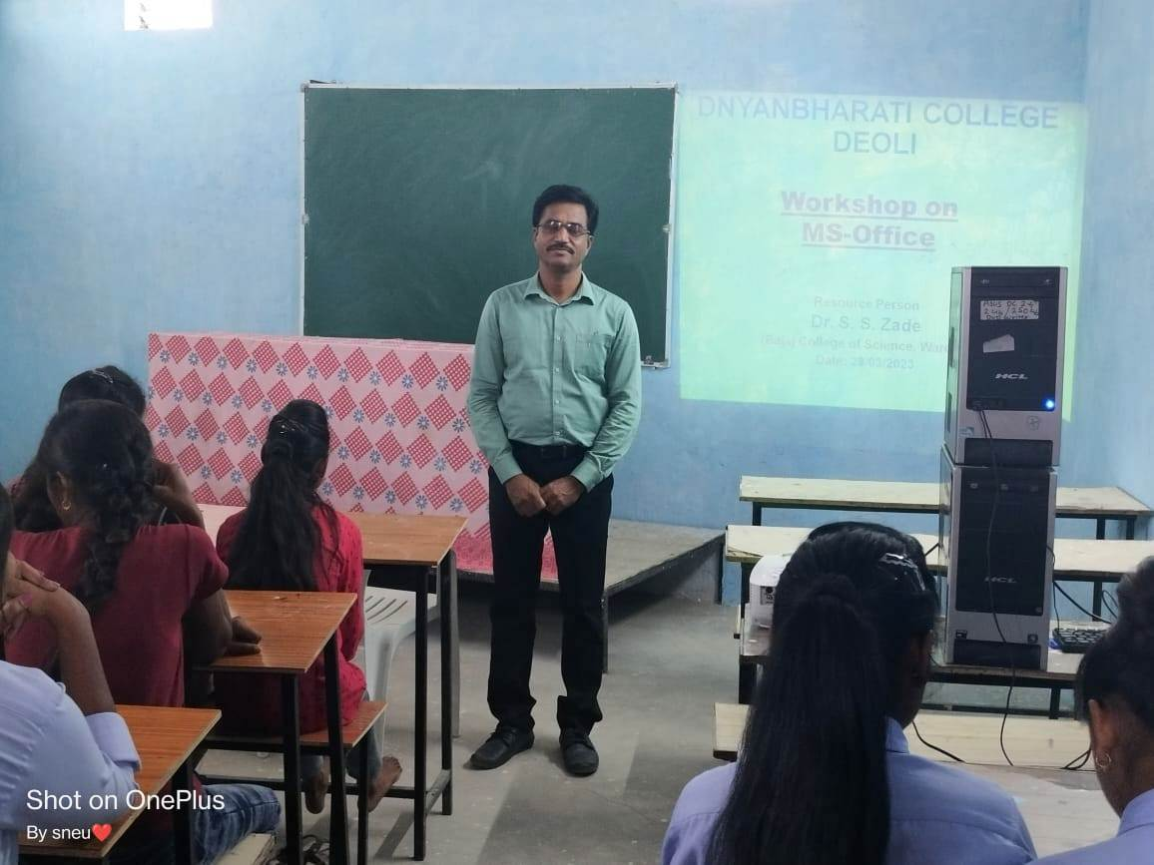
WORKSHOP ON MS-OFFICE
Dept. Of Mathematics Dnyanbharati College Deoli has organized the Workshop on MS-Office on 28/03/2023, Dr. S. S. Zade HOD, Bajaj Science College, Wardha was the Resource Person of the Workshop. Prof. S. A. Upadhye has taken initiative of the Workshop. Prof. Sneha Kamde has presents the Vote of Thanks.

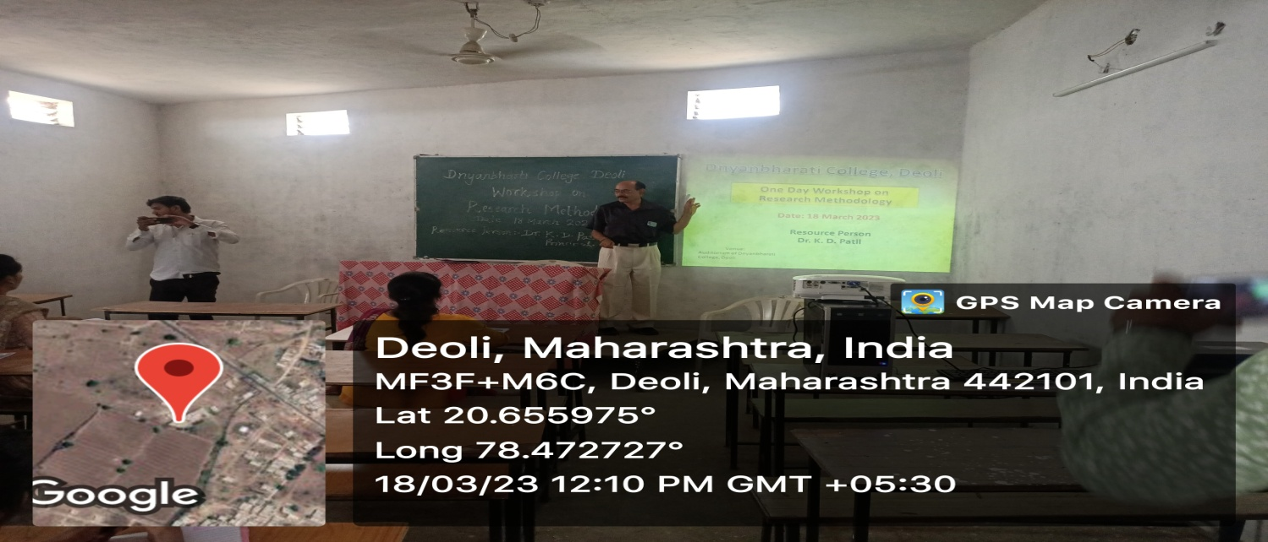
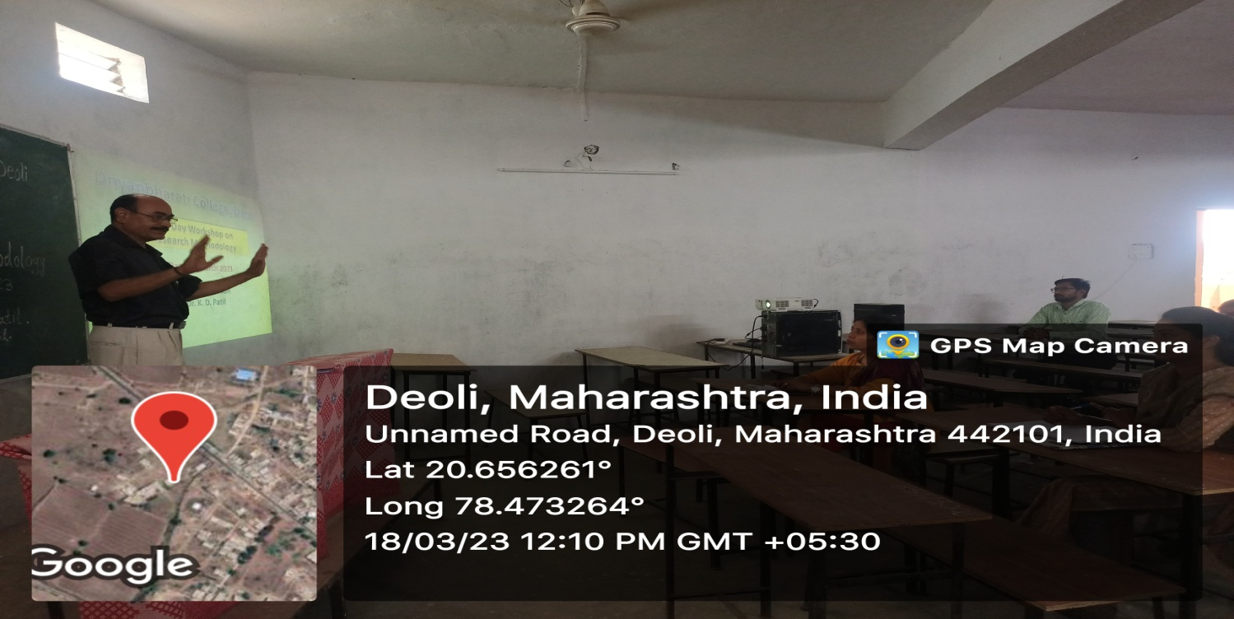
WORKSHOP ON RESEARCH METHODOLOGY
On 18/03/2023 a Workshop on Research Methodology has been organized by Dnyanbharati College Deoli in Auditorium Hall. All Teaching faculties of each department has attended the Workshop. Resource Person of this workshop was Dr. K. D. Patil, Principal and the Special Guest was Dr. Pritam B. Khadse, Secretary. Dr. K. D. Patil has explained the importance of research methodology in Ph.D research work.

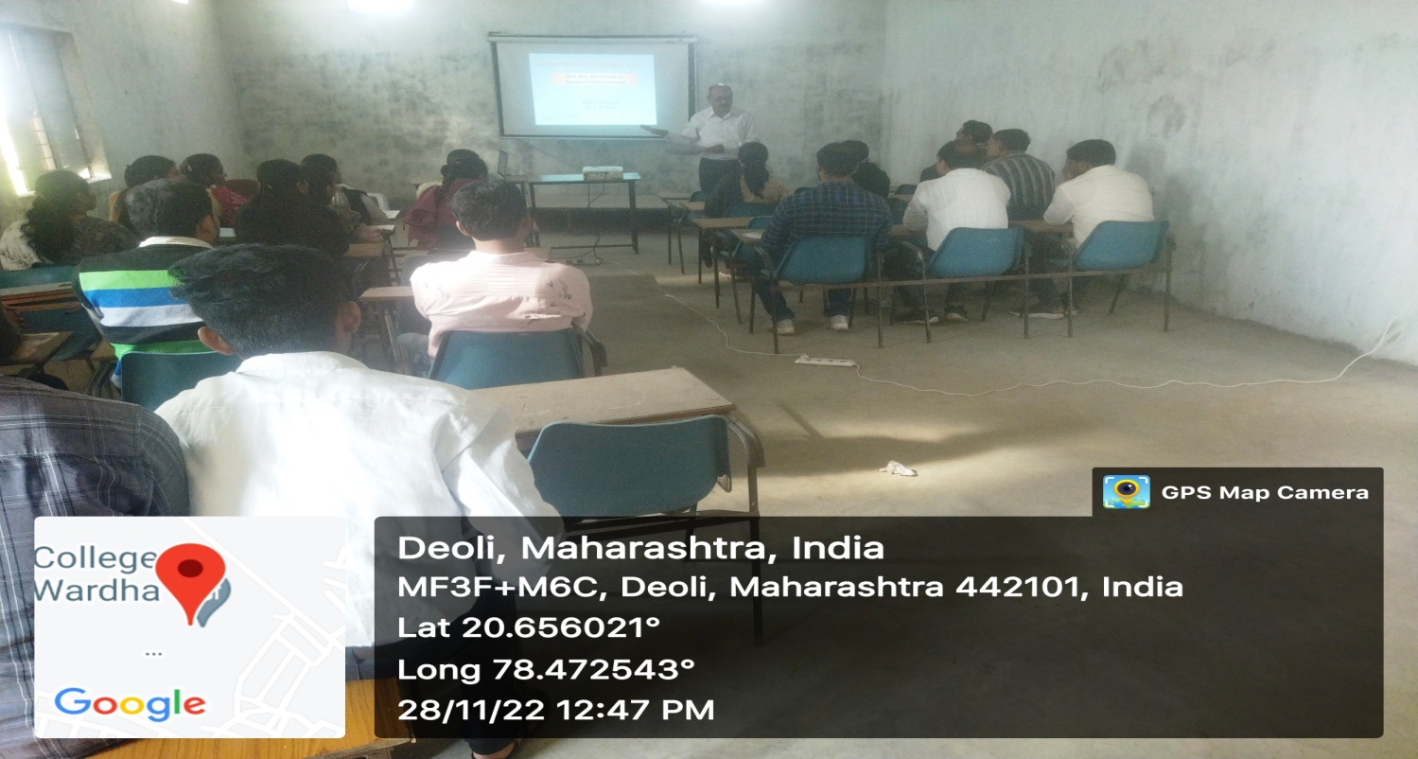
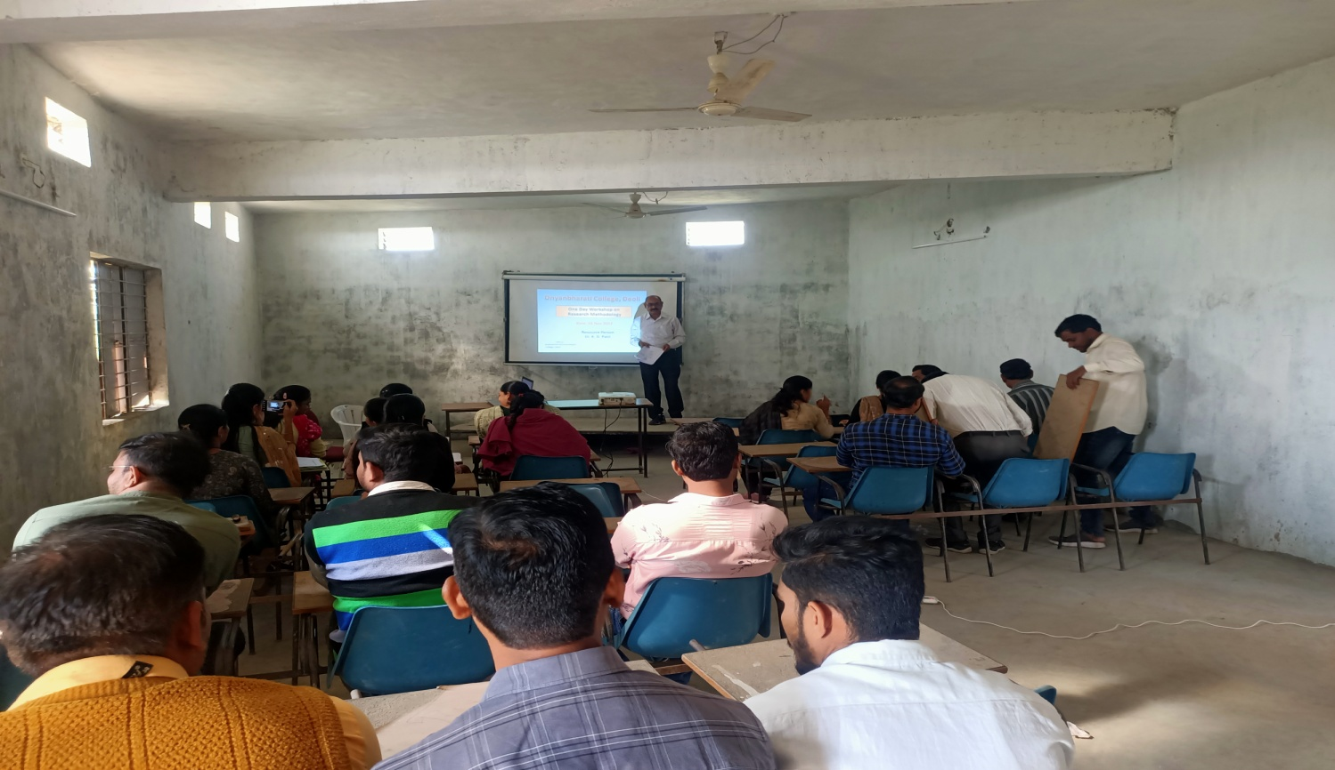
WORKSHOP ON RESEARCH METHODOLOGY
Dnyanbharati College Deoli has organized a workshop on research methodlogy on 28/11/22. The Resource Person for this workshop was Dr. K. D. Patil, Principal. All Teaching faculties have attended the Workshop. Prof. V. V. Takpire has given the introductory Speech and Prof. A. G. Adkane presents the Vote of Thanks.
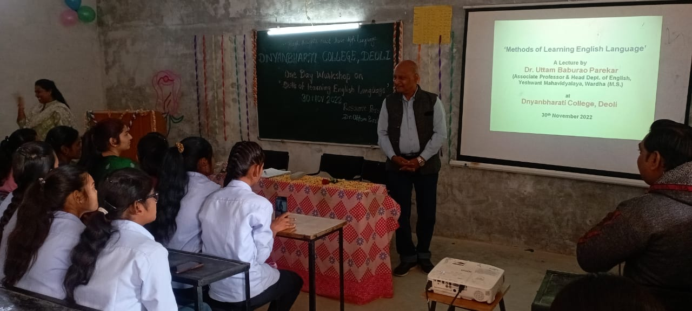
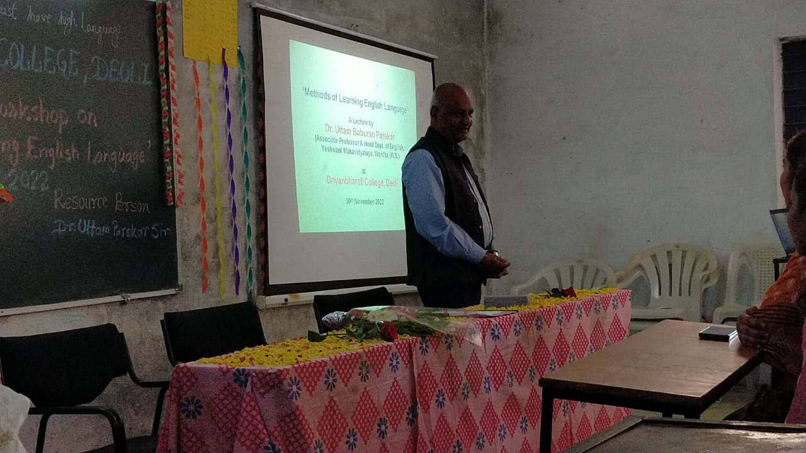
WORKSHOP ON METHOD OF LEARNING ENGLISH LANGUAGE
Dept. Of English Dnyanbharati College Deoli has organized One day Workshop On Methods of Learning English Language Dr. Uttam Parekar Yashwant Mahavidyalaya Wardha was the Resource Person for this Workshop. At the inauguration session Dr. K. D. Patil Principal of the college has welcome the guest and gave introductory speech. Prof. Shamina from English Dept. Has organized this programme. There were about 50 participants for this workshop. At the ned of workshop Prof. Archana Barange has given the Vote of Thanks

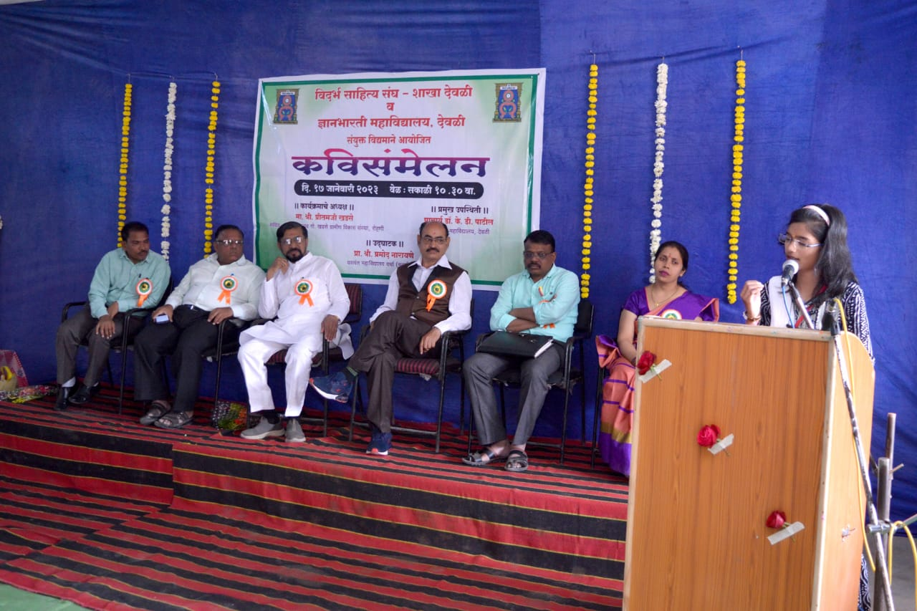
MARATHI POETRY WORKSHOP
Dept. Of Marathi Dnyanbharati College Deoli has organized the Marathi Poetry Workshop on dated 17/01/2023. Chairman of the workshop Dr. Ganesh Maldhure, Presidents of Vidharbha Sahitya Sangha Branch Deoli, Cheif Guest of the workshop was Dr. Pramod Narayane, President of Visharbha Sahitya Sangh, Maharashtra. Many poets from different part region of the states have participated in this workshop.

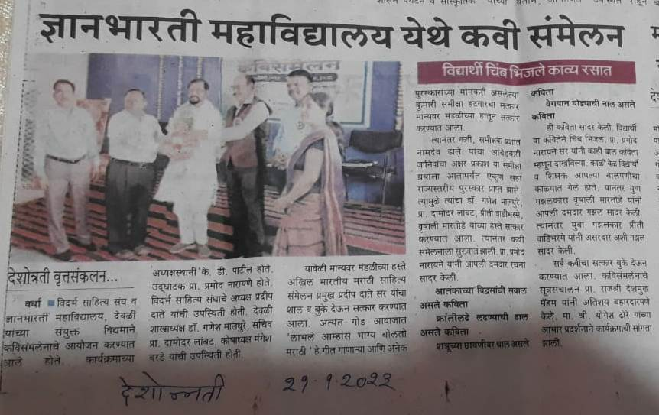
News Cut-out of the MARARTHI POETRY WORKSHOP published in the Marathi Daily Newspaper “ Deshonnati” on dated 21/01/2023

- . REPORT OF ONE DAY WORKSHOP ON
PATTERN MAKING AND FABRIC CUTTING

Department of Fashion Designing Dnyanbharati College has organised one day workshop on Pattern making and fabric cutting dated on 28/11/2022. The resource person of workshop was Prof. Vaishali V. Takpire Deoli.

At the beginning of workshop, Principal Dr. K. D. Patil has welcome the Prof. Vaishali V. Takpire. Explain the importance of fabric cutting workshop and delivered talk on how to pattern making and fabric cutting and importance of pattern making and fabric cutting solve all queries of students. Mostly students participated in workshop. Prof. Sneha Kamde has given the votes of thanks at the end of workshop.

□ ORGANISED BY
DEPARTMENT OF FASHION DESIGNING
- PRINCIPAL » SPEAKER » DATE AND TIME
Dr. K.D.Patil Prof. Vaishali V Takpire 28/11/2022 AND
Dnyanbharati College Deoli Dnyanbharati College Deoli 1.00 TO 4.00 PM

- VENUE :- FASHION DESIGNING LAB, DNYANBHARATI COLLEGE DEOLI

DNYANBHARATI COLLEGE DEOLI

ONE DAY WORKSHOP ON
PATTERN MAKING AND FABRIC CUTTING
SESSION 2022-23

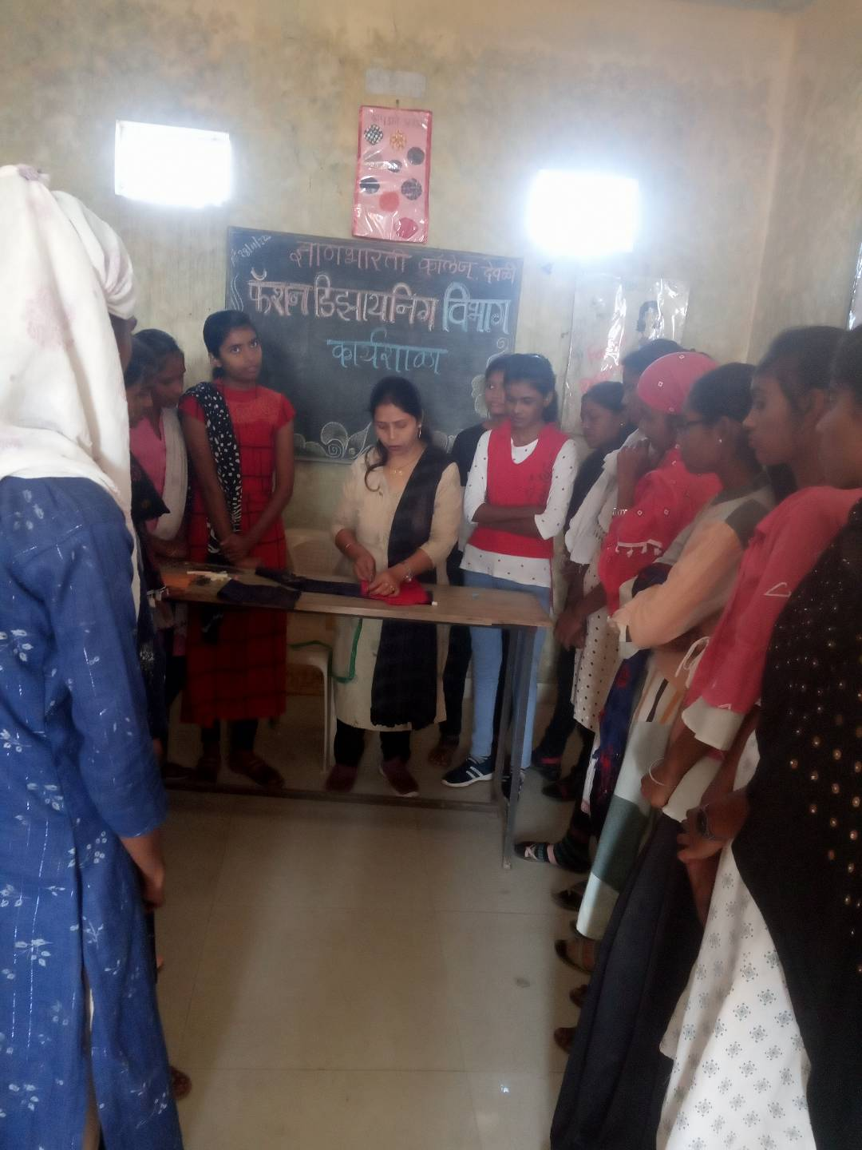
ONE DAY WORKSHOP ON PATTERN MAKING AND FABRIC CUTTING
Prof. Vaishali Takpire Conducting the Workshop

Academic Session 2021-22

- REPORT OF ONE DAY WORKSHOP ON
TIE AND DYE ( BANDHANI)

Department of Fashion Designing Dnyanbharati College has organised one day workshop on TIE and DYE dated on 07/01/2022. The resource person of workshop was Prof. Swati Sangloodkar, S.S.N.J Mahavidyalaya Deoli.

At the beginning of workshop, Principal Dr. Shubhangi Dange has welcome the guest. Prof. Swati Sanglodkar explain the importance of workshop and delivered talk on how to Fabric Tie and Dye method works, and importance of Bandhani and solve all queries of students. Mostly students participated in workshop. Prof. Shamina Sayyad has given the votes of thanks at the end of workshop.

□ ORGANISED BY
DEPARTMENT OF FASHION DESIGNING
- PRINCIPAL » SPEAKER » DATE AND TIME
Dr. Shubhangi Dange Prof. Swati Sangloodkar 07/01/2022 AND
Dnyanbharati College Deoli S.S.N.J Mahavidyalaya Deoli 1.00 TO 4.00 PM

- VENUE :- FASHION DESIGNING LAB, DNYANBHARATI COLLEGE DEOLI
DNYANBHARATI COLLEGE DEOLI
ONE DAY WORKSHOP ON
TIE AND DYE ( BANDHANI)
SESSION 2021-22

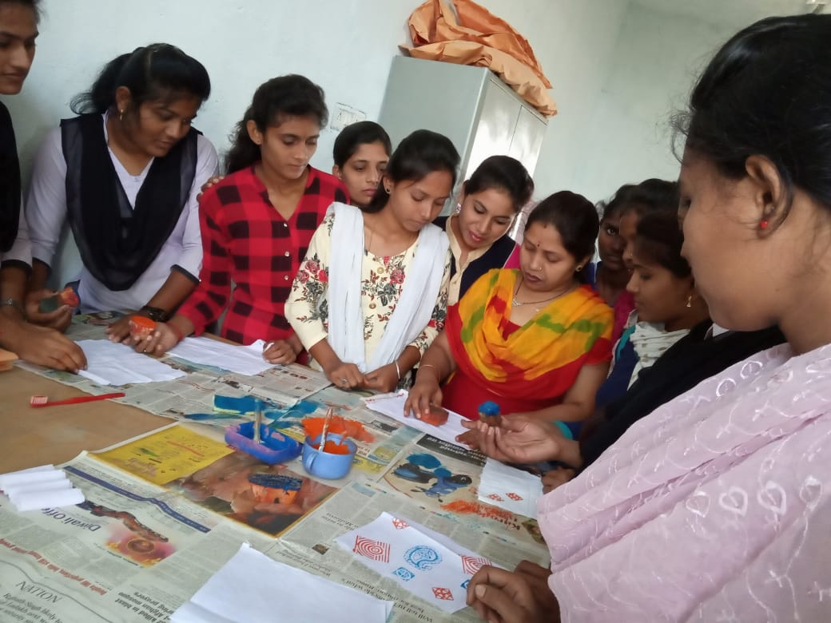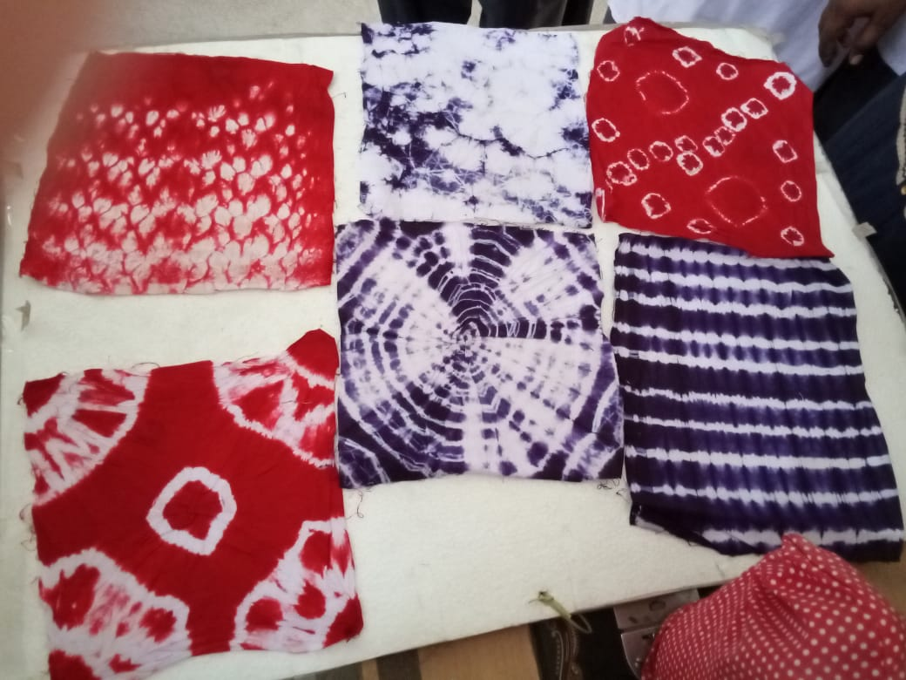
WORKSHOP ON TIE AND DYE (BHANDANI)

- REPORT OF ONE DAY SEMINAR ON SPECTROSCOPY
Department of Chemistry Dnyanbharati college has organized one day Seminar on Spectroscopy dated on 05/08/2021 . The resource person of Seminar was Asst. Prof. Jagruti Panchavani RDIK AND KDK COLLEGE BADNERA , AMRAVATI.

At the beginning of Seminar Principal has welcomed the guest. Asst. Prof. Jagruti panchavani explains the importance of Spectroscopy Seminar. Asst. Prof. Jagruti panchavani has delivered talk on Spectroscopy. Students listen carefully and ask questions and guest satisfies all the queries. Prof. Sneha Kamde has given the Vote of thanks at the end of Seminar.

Organized by Department of Chemistry

■ PRINCIPAL ■ SPEAKER DATE & TIME Dnyanbharati College Deoli Ass. Prof. Jagruti panchavani 05/08/2021
11am to 1Pm

VENUE:- DEPARTMENT OF CHEMISTRY, DNYANBHARATI COLLEGE ,DEOLI.

DNYANBHARATI COLLEGE DEOLI

ONE DAY SEMINAR ON TOPIC spectroscopy SESSION 2021-2022

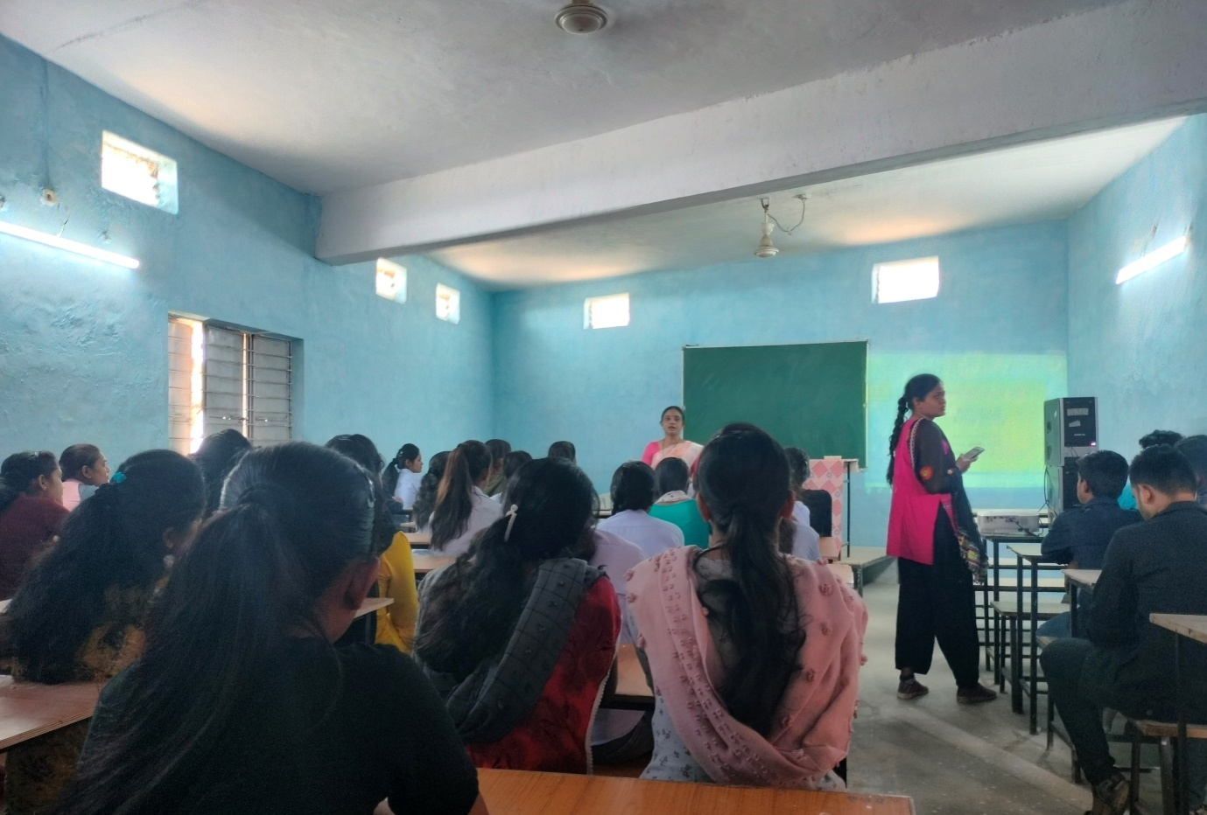
ONE DAY SEMINAR ON SPECTROSCOPY

One Day Workshop Report On Farmer’s Suicide
Department of Sociology Dnyanbharati College Deoli has organized One Day Workshop on “Farmer’s Susuide” dated on 17 Dec 2021. The Resource Person of Workshop was Mr.Rohan Kamble, Vidarbh Irrigation Development Corporation Nagpur.
At the beginning of Seminar Principal has welcomed the guest. Mr.Rohan Kamble explained the importance of workshop. He guided to the students about Farmer’s Susuide Causes,Effects of Susuide. 70 students participated in the workshop. Prof. Ashwini Wagh has given the votes of thanks at the workshop. In this workshop teaching and non teaching staff also present.

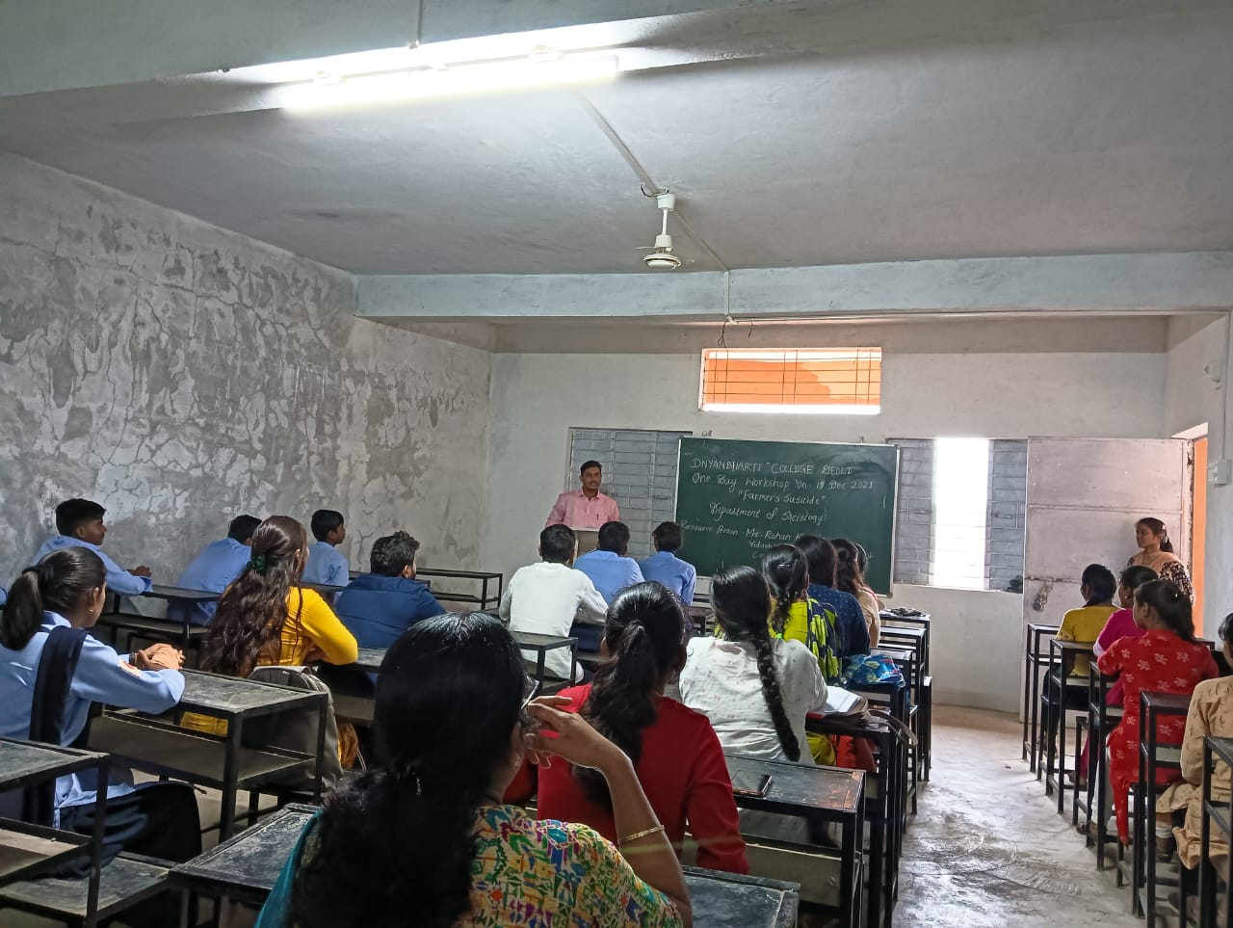
Mr. Rohan Kamble Delivering the lecture on Farmer’s Suicide in Workshop.

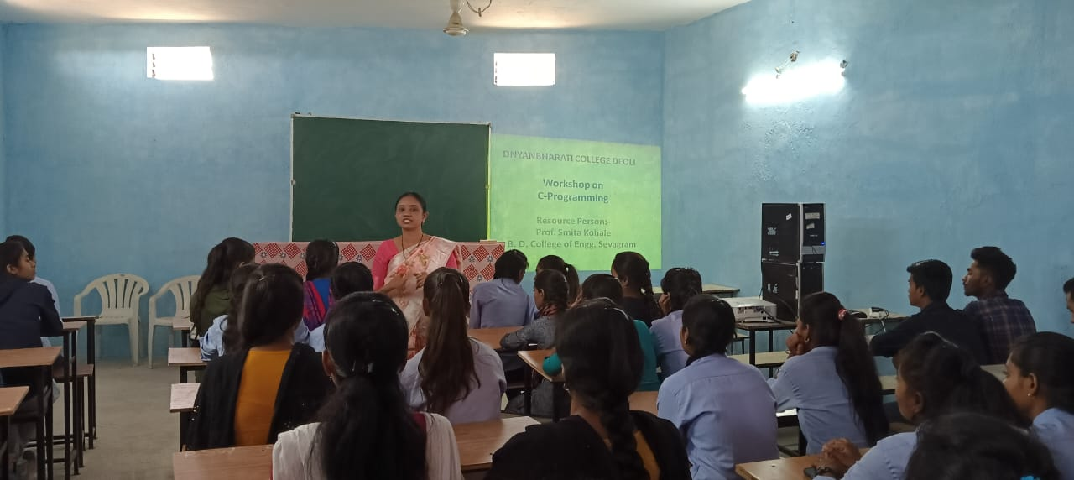
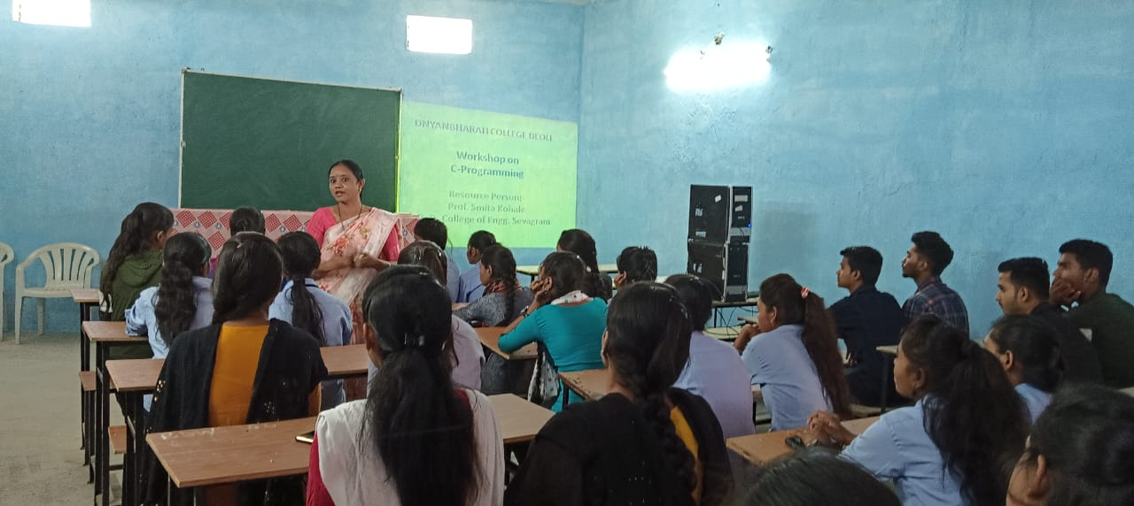
WORKSHOP ON C-PROGRAMMING
Dr. Smita Kohale, Asst. Professor in Mathematics, B. D. Engineering College, Wardha was conducting the Workshop on C-Programming organize by the Mathematics Dept. Dnyanbharati Collge Deoli on 01/04/2022. Prof. S. A. Upadhye has taken the efforts for the successfully completion of the Workshop. 40 number of students were participated in the Workshop.

Academic Session 2019-20
- REPORT OF ONE DAY SEMINAR ON
SEWING MACHINE MAINTENANCE
Department of Fashion Designing, Dnyanbharati College has organised one day Seminar on Sewing Machine Maintenance dated on 10/01/2020. The resource person of Seminar was Mr.Shyam Tayade.Wardha

At the beginning of Seminar, Prof. Vaishali Takpire has welcome the guest Mr. Shyam Tayade . Approximately 25 students participated in seminar Prof. A. J. Dhakade has given the Vote of Thanks at the end of seminar.

□ ORGANISED BY
DEPARTMENT OF FASHION DESIGNING
» SPEAKER » DATE AND TIME
Mr.Shyam Tayade 10/01/2020
Machine Mechanical .Wardha. 1.00 TO 4.00 PM

- VENUE :- FASHION DESIGNING LAB, DNYANBHARATI COLLEGE DEOLI

DNYANBHARATI COLLEGE DEOLI
ONE DAY SEMINAR ON
SEWING MACHINE MAINTENANCE
SESSION 2019-2020

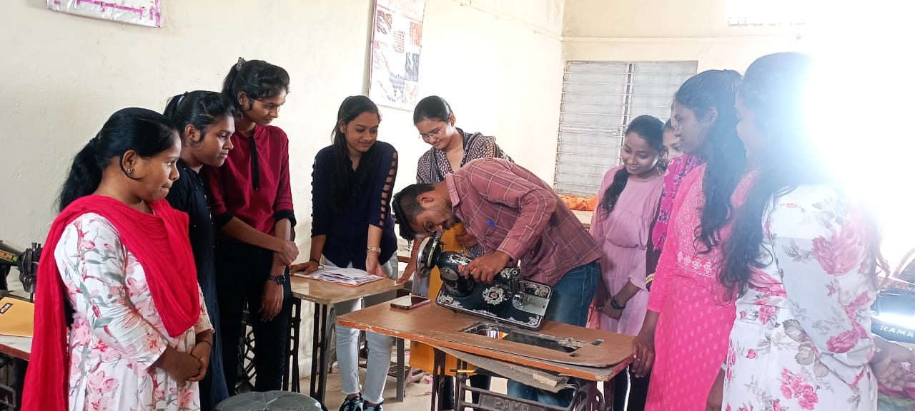
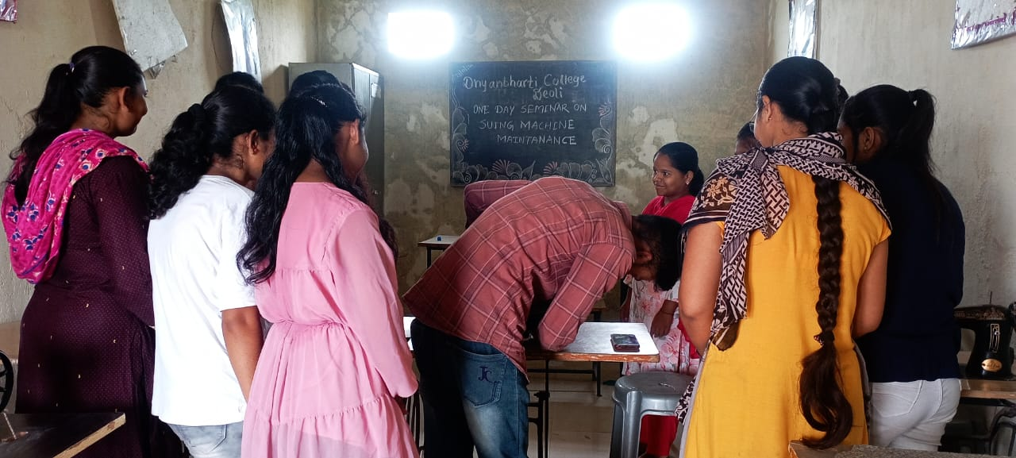
ONE DAY SEMINAR ON MAINTAINANCE OF SEWING MACHINE

Report
On
One Day Seminar
Department of Sociology Dnyanbharati College Deoli has organized One Day Seminar on “Social Problems” dated on 11 Feb 2020. The Resource Person of Seminar was Prof. A. D. Barange, Dnyanbharati College Deoli.
At the beginning of Seminar Principal Dr. Ashok Kale has welcomed the guest. Prof A. D. Barange explained the importance of Seminar. She guided to the students about social problems (Social Disorganisation, Social inequality, Overpopulation, Age Discrimination etc). Mostly students were present to the Seminar. Prof. V. V. Takpire has given the votes of thanks at the Seminar. 25 students were participated in seminar.
Dnyanbharati College Deoli

Organized by
DEPARTMENT OF SOCIOLOGY
Speaker
Prof. A. D. Barange
Dnyanbharati College Deoli

One Day Seminar on Social Problem’s
Session 2019 - 2020

Date And Time
11 Feb 2020
12.00 pm to 1.00pm
Principal
Dr. Ashok Kale
Dnyanbharati College Deoli

Venue: Hall No. 05
Dnyanbharati College Deoli

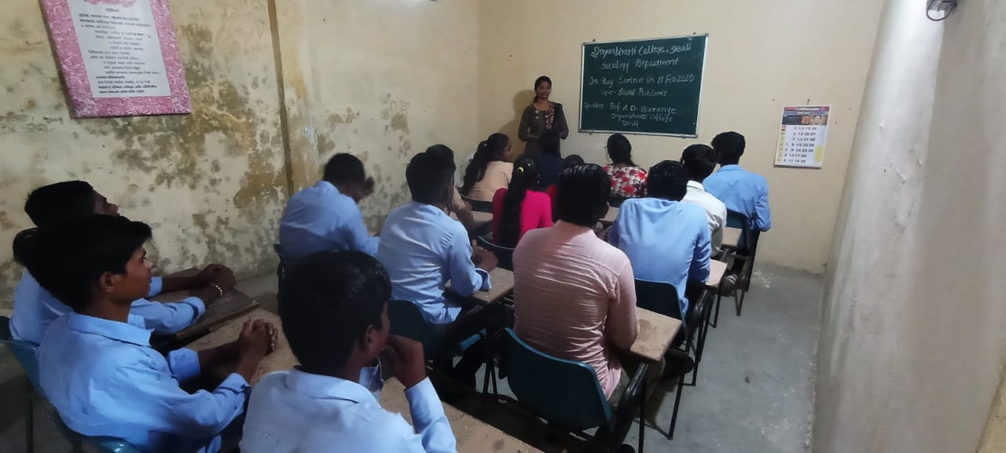
ONE DAY SEMINAR ON SOCIAL PROBLEMS

Academic Session 2018-19
REPORT OF ONE DAY SEMINAR ON
AWARENESS OF FASHION

Department of Fashion Designing Dnyanbharati College has organised one day Seminar on Awareness of fashion dated on 11/12/2018. The resource person of Seminar was Mrs. Archana Nakhale Wardha.

At the beginning of Seminar, Principal Dr. Ashok Kale has welcomed the Mrs. Archana Nakhale. Explain the students that fashion needs time and we should change according to the changing time and delivered talk on solve all queries of students. Mostly students participated in Seminar. Prof. Vaishali Takpire has given the votes of thanks at the end of Seminar. 25 students were participated in seminar.

□ ORGANISED BY
DEPARTMENT OF FASHION DESIGNING
- PRINCIPAL » SPEAKER » DATE AND TIME
Dr.Ashok Kale. Prof. Archana Nakhale 11/12/2018 AND
Dnyanbharati College Deoli Chetana Vikas, Wardha. 1.00 TO 4.00 PM

- VENUE :- DNYANBHARATI COLLEGE DEOLI

DNYANBHARATI COLLEGE DEOLI

ONE DAY SEMINAR ON
AWARENESS OF FASHION
SESSION 2018-2019

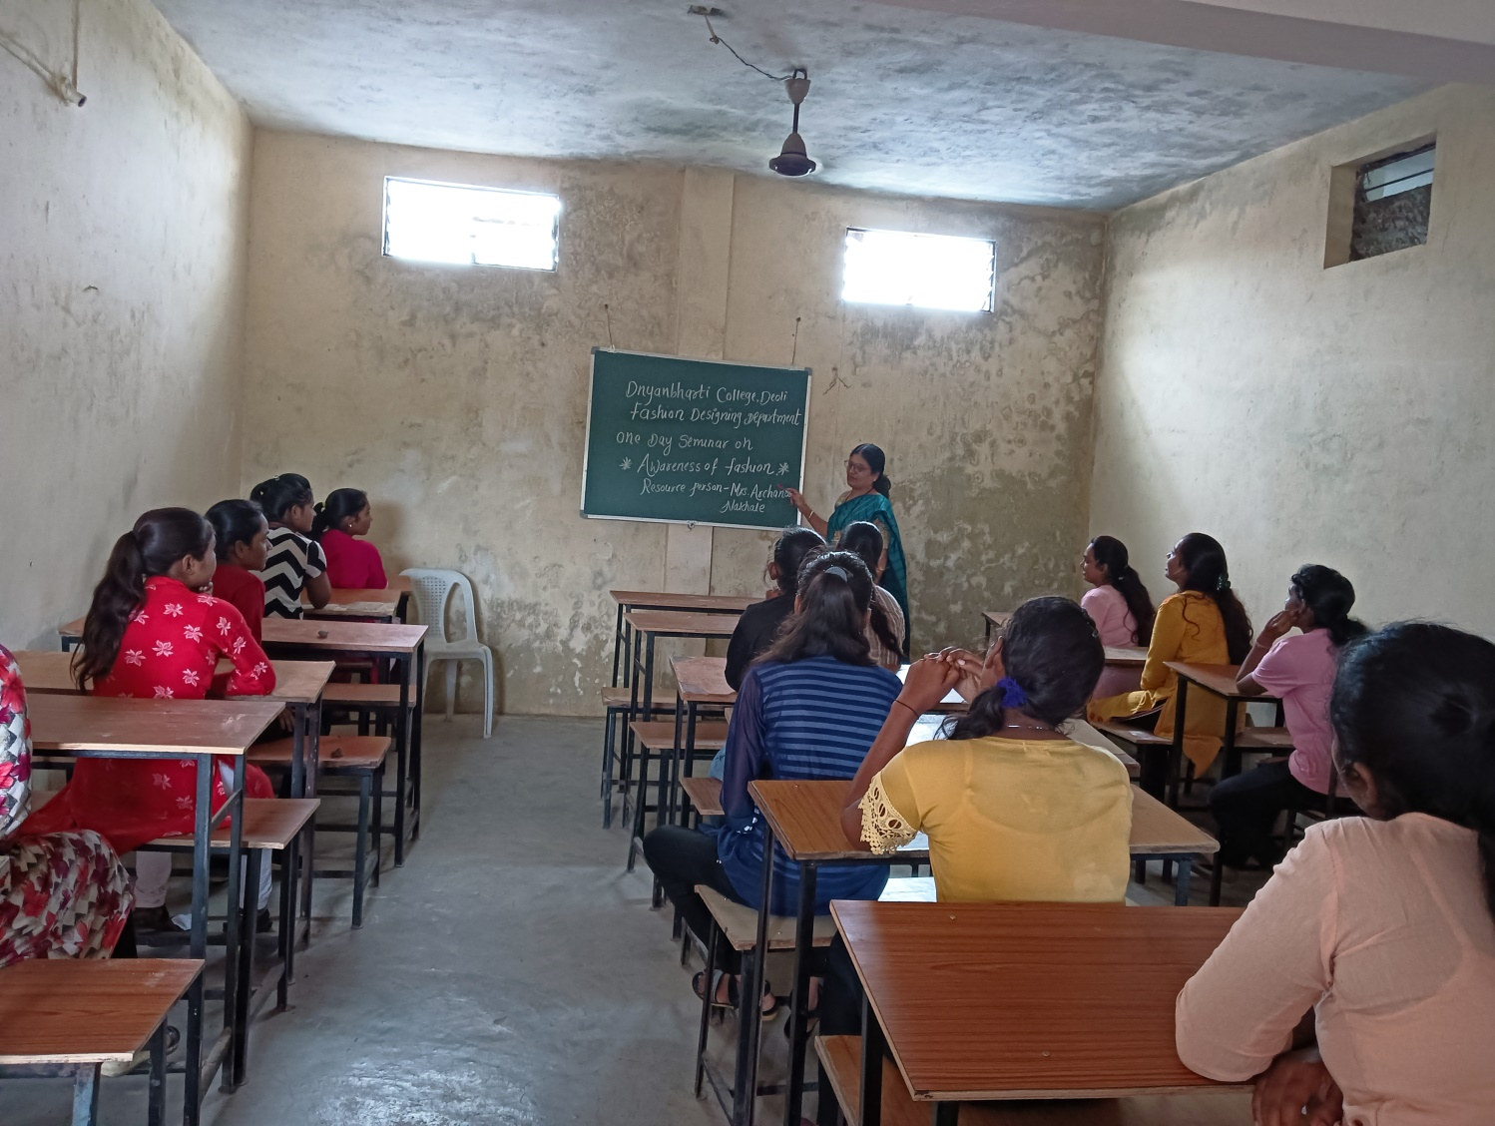
ONE DAY SEMINAR ON AWARENESS OF FASHION

Dnyanbharati College Deoli
Dnyanbharati College Deoli

Session 2018-19
Organized By
Department of political science

ONE DAY WORKSHOP
On
RIGHT TO INFORMATION ACT

Speaker
Prof. A. G. Adkane, Dnyanbharati College , Deoli

Venue
Seminar Hall
Dnyanbharati College,
Deoli

Date & Time
22 Jan 2019
11 am to 12 pm

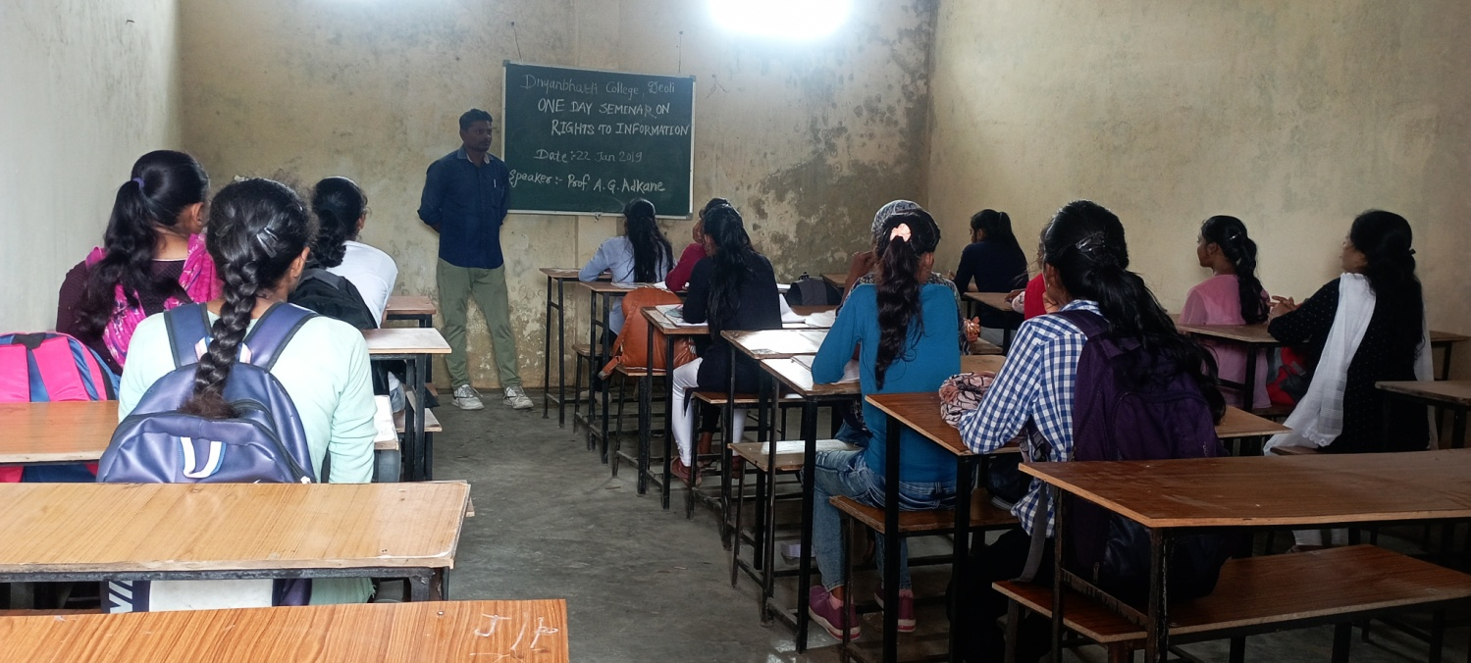
Prof. A. G. Adkane Delivering lecture in Right to Information Act Workshop

